WILL CLIMATE CHANGE AFFECT WHAT’S ON OUR PLATES?
By LUNA HUSSein DATE august, 2019
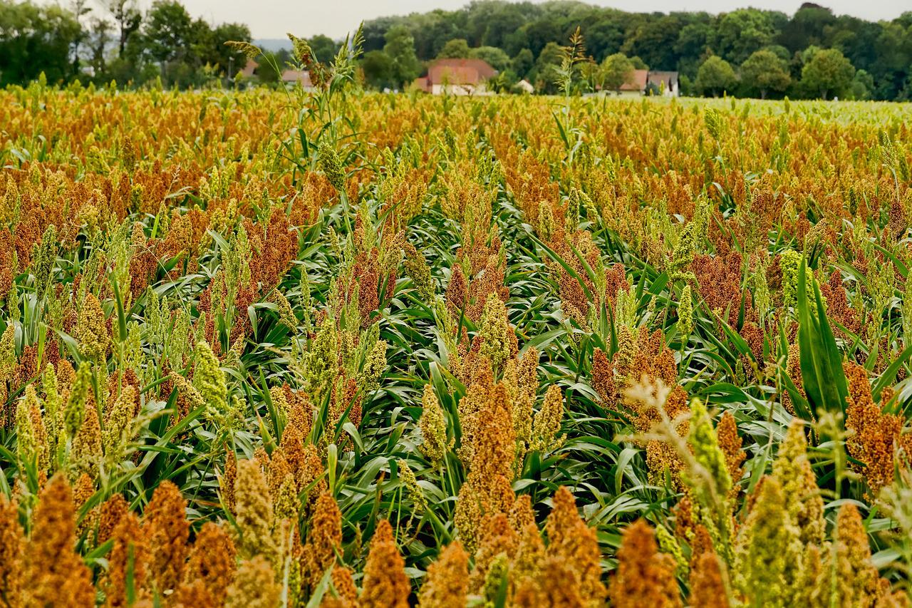
Climate change is affecting the growth of traditional grains such as wheat, meaning that people might need to get used to different grains, such as sorghum (above).
Image from pixabay

Answer the following questions in full sentences:
- What is this news story about?
A poor harvest in France as a result of a number of smaller factors rather than one big environmental event and the impact this could have on future farming techniques.

- What were the causes of this poor harvest?
- An unusually warm winter
- Intense rains leached nutrients out the soil
- Heat and damp increased the spread of diseases.

- Why did this poor harvest not affect many French people?
Because France is a wealthy country and had other sources of grain and food.
- What effect could a poor harvest have on a less wealthy country?
Worsen poverty or cause a famine.
- How will climate change how farmers work?
- Less food will be produced
- Some crops may be less nutritious
- More climate change/drought tolerant crops may be grown
- Farmers will have to work harder to bring crops to harvest

- Write down the meanings of any words in bold in the article.
Harvest – the process/period of gathering crops
Yields – the amount produced through an agricultural or industrial process
Leached – drainage of minerals by rainwater
Famine – extreme food shortages/scarcity of food
Vulnerable – exposed to the possibility of being harmed
Drought – a period of abnormally low rainfall, usually leading to water shortages

